**First level.**

Create a set of GET, POST, PUT, PATCH, DELETE requests to the JSONPlaceholder that are sent within 10 seconds in 3 iterations.

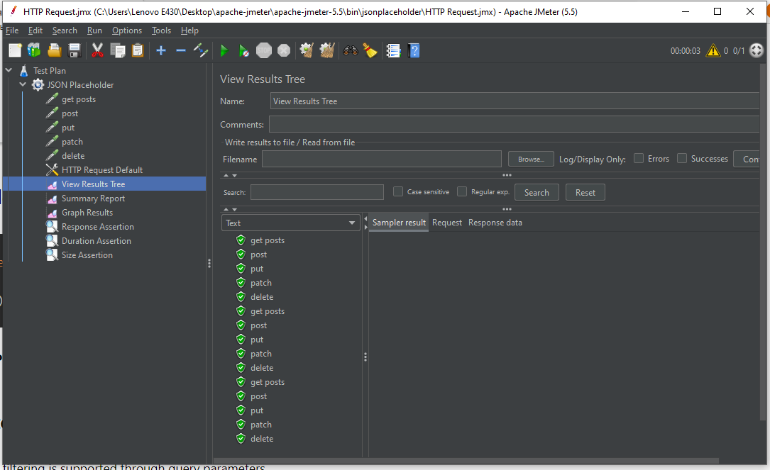

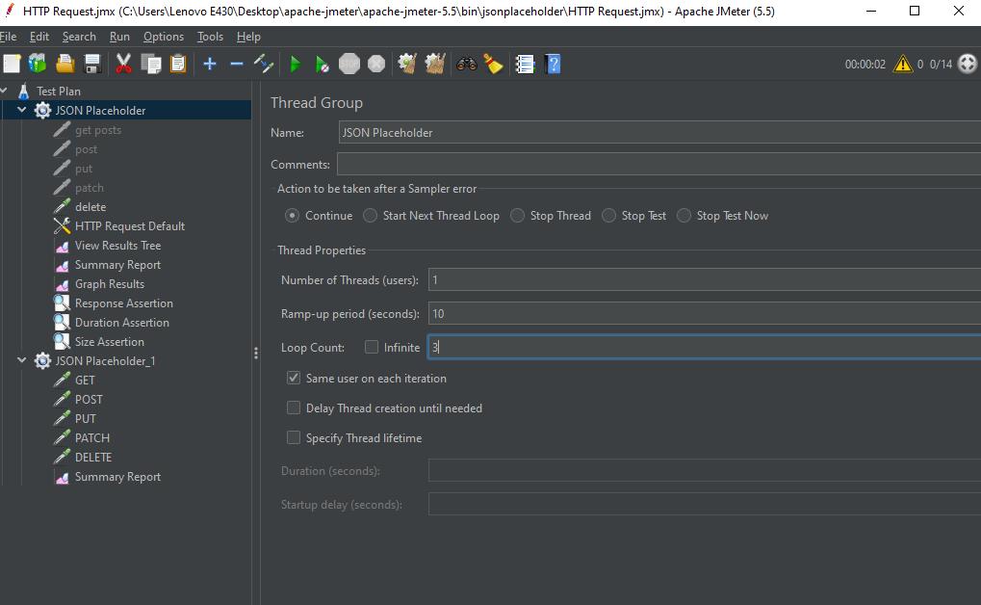

Apply 3 different assertions to each of the queries.

* response assertion:

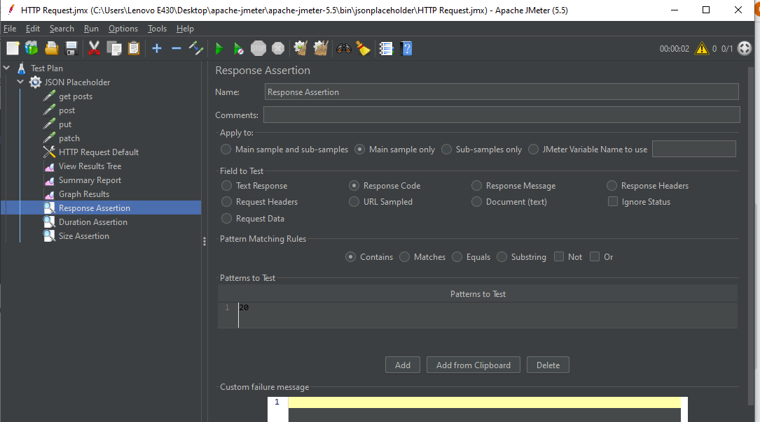

* duration assertion:

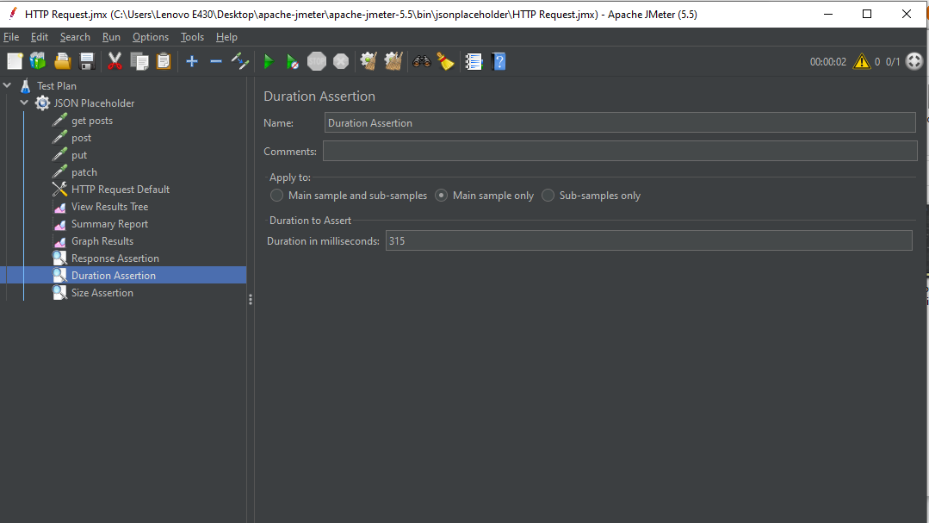

* size assertion:

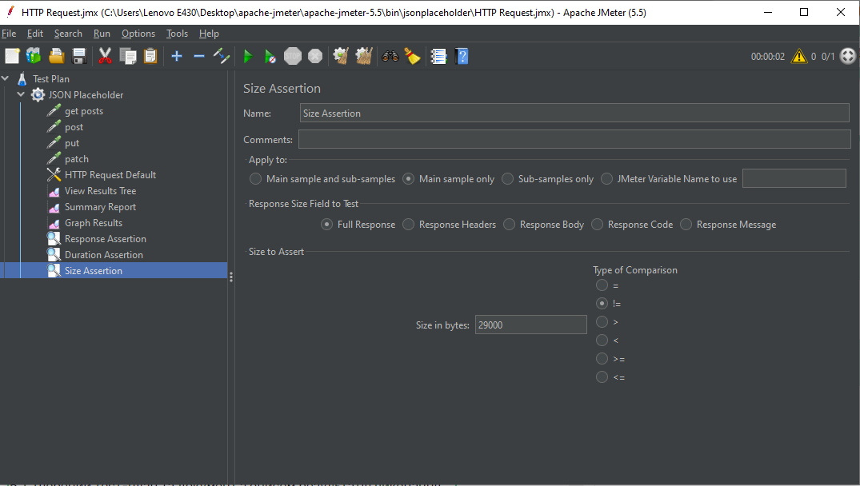

Listener - Summary report:

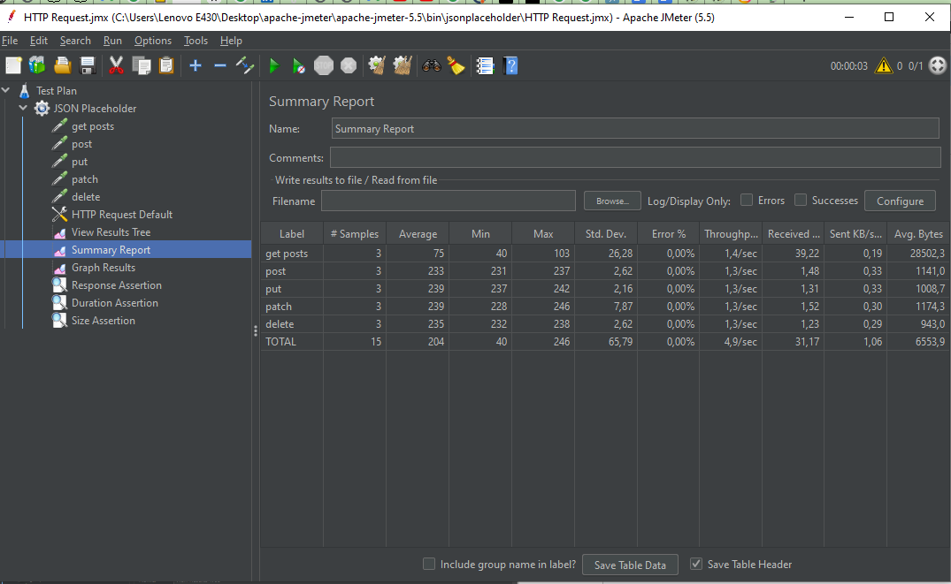

Listener - View Results in Tree:



The conclusion is that the system operates stably in the given conditions:

number of thread (user) - 1;

rump-up period (second) - 10;

loop count - 3.

Conclusions on the test results:

1. 15 requests were made.
2. Average response time - less than 1 second.
3. The number of requests was 1.3;1.4 per second.
4. Number of errors - 0%.

.

**Second level.**

**Run a stress test for each of the requests.**

Stress test for GET request, with 50 users, the system works stably:

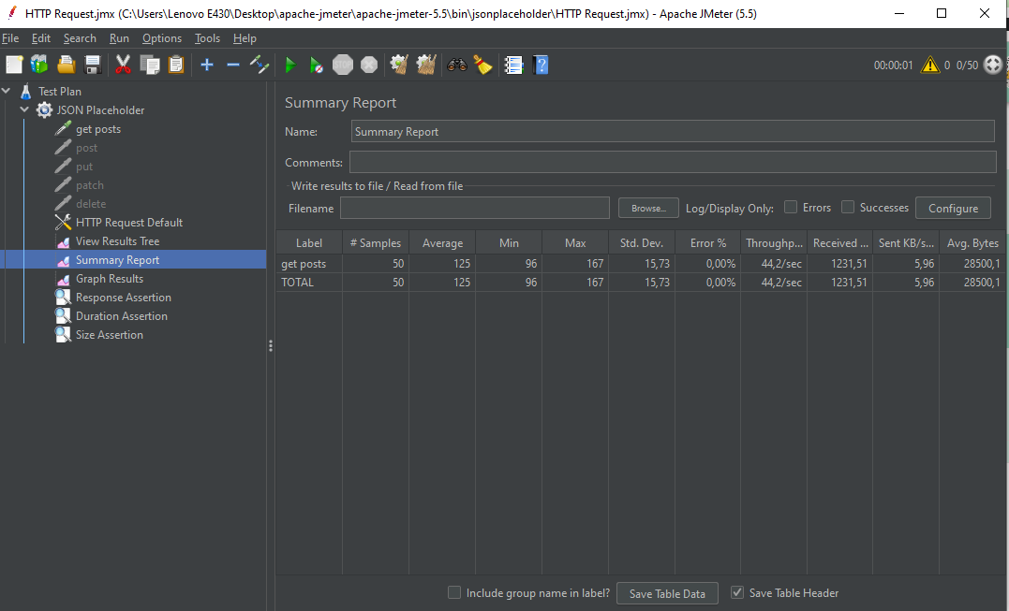

Stress test for GET request: with 60 users, the system works not stably:

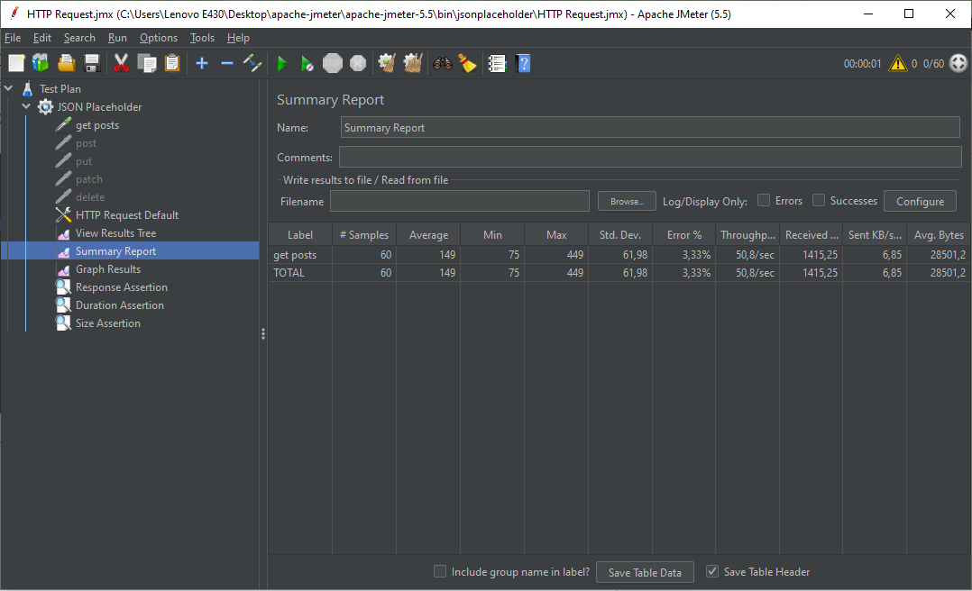

Stress test for POST request, with 40 users, the system works stably:

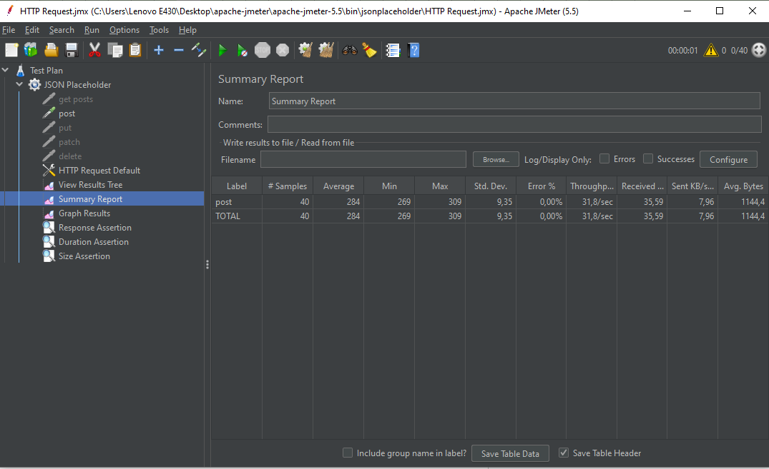

Stress test for POST request, with 50 users, the system works not stably:

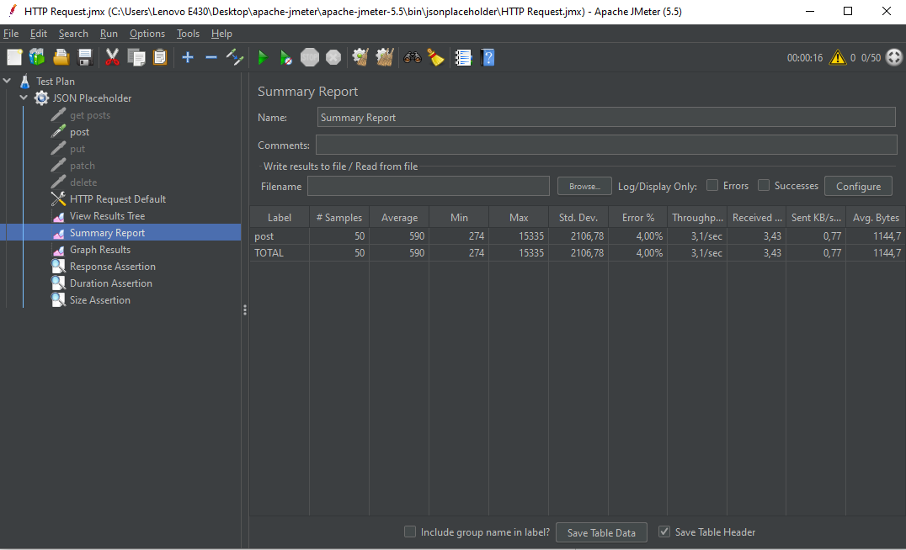

Stress test for PUT request, with 10 users, the system works stably:

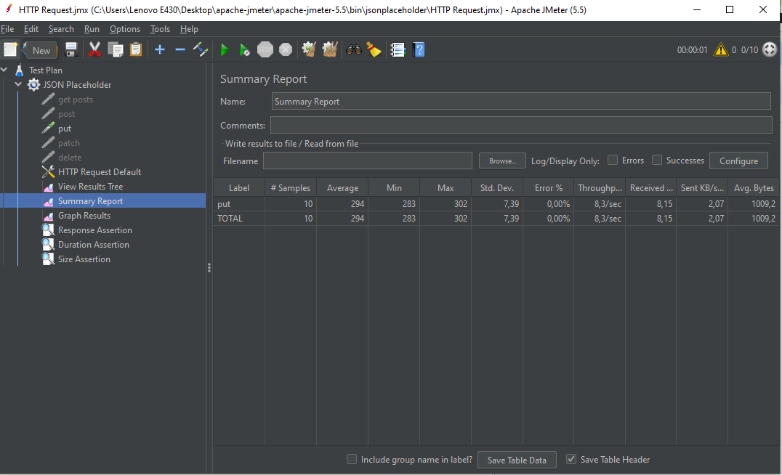

Stress test for PUT request, with 15 users, the system works not stably:

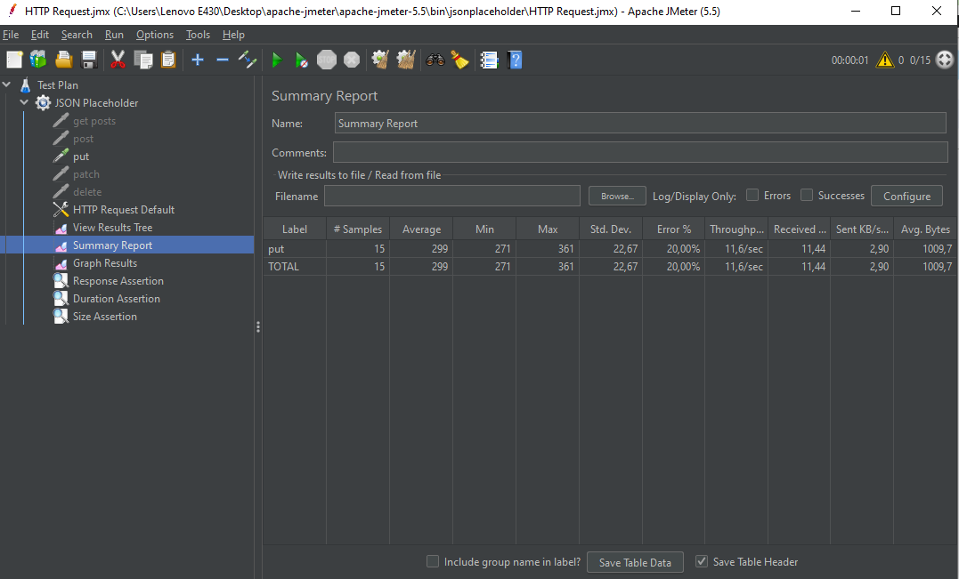

Stress test for PATCH request, with 10 users, the system works stably:

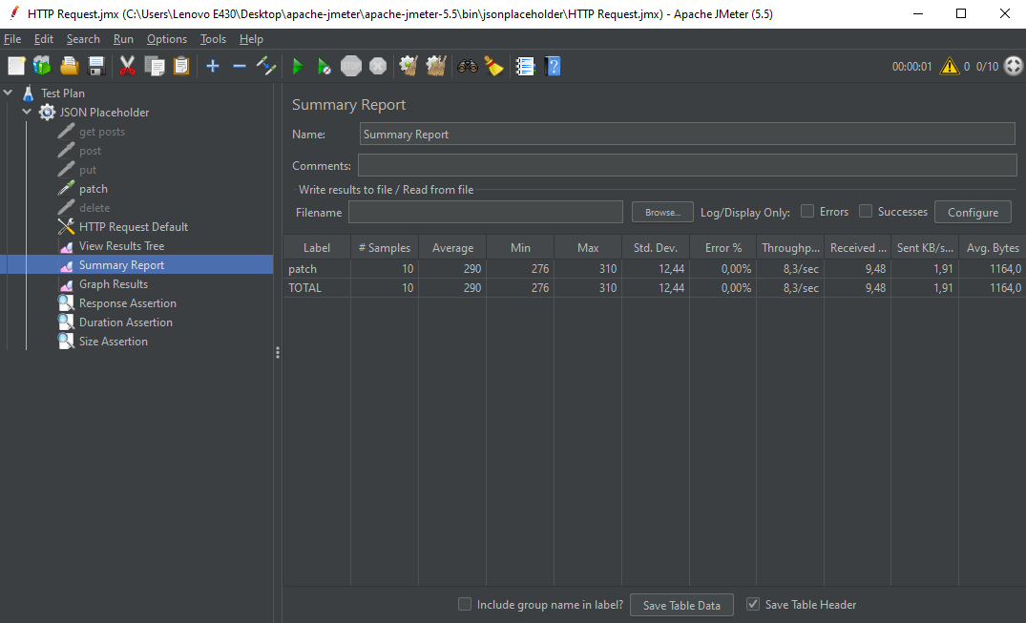

Stress test for PATCH request, with 15 users, the system works not stably:

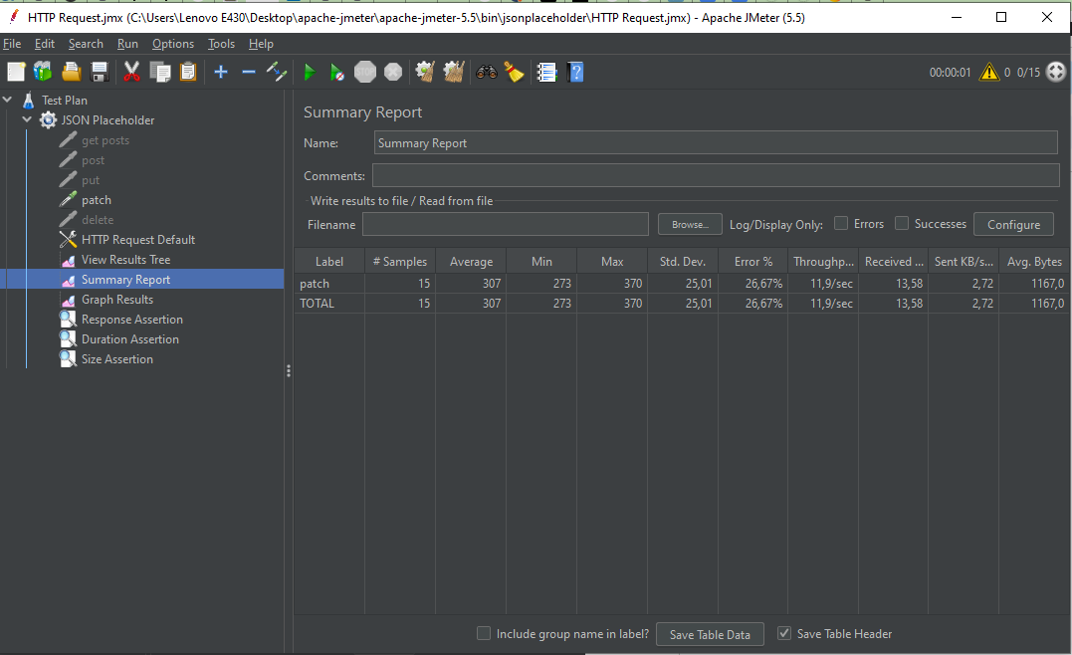

Stress test for Delete request, with 6 users, the system works stably:

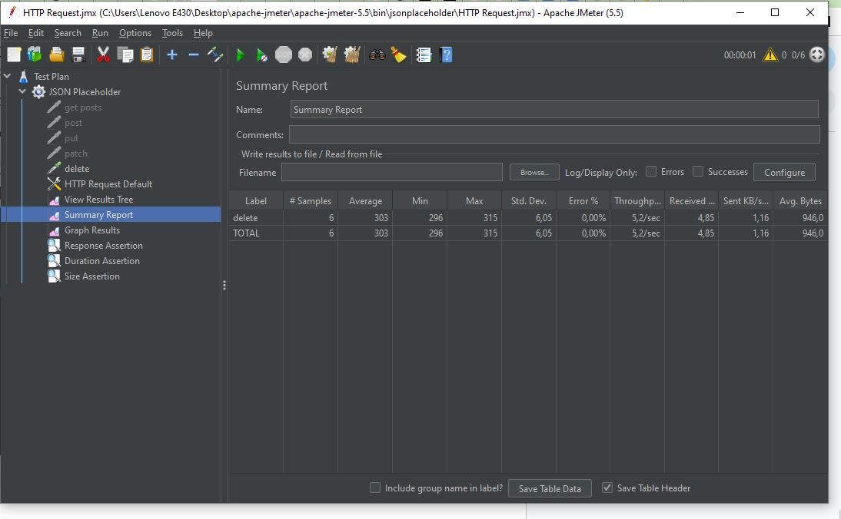

Stress test for PATCH request, with 7users, the system works not stably:

